Building Huffman Trees
The first and most fundamental step of building a Huffman tree is calculating the occurrences of each character. Since we’ll be using Python, a dictionary data structure would be the easiest way to do this.
Now suppose this is the current, character occurrence chart. What we want to do is start by grouping the two least occurring nodes (characters) and join them. This will be considered a new node with an occurrence value being the sum of the values of both the nodes, i.e. the total occurrences of both these characters.
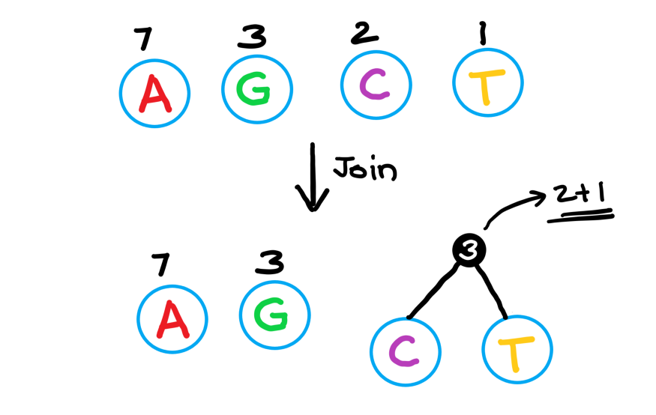

Now we take the next two lowest value nodes and join them too. Once we join two nodes, we start considering them as one combined unit node.
We repeat this step until there is only one node in total. This node is our Huffman tree.
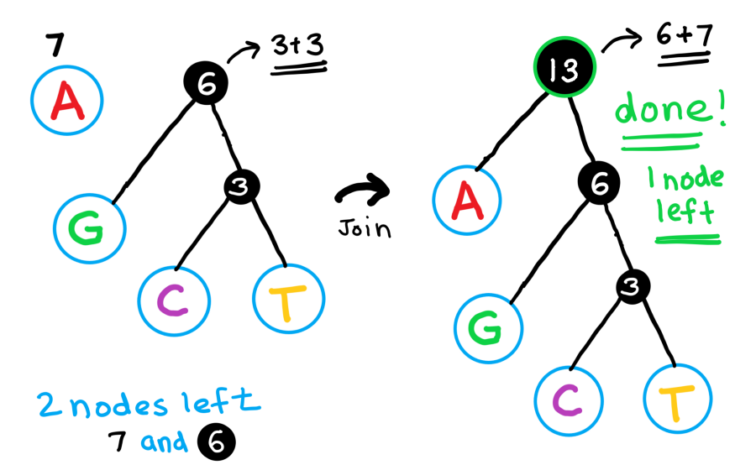

Now, to find the new representation of each character, we add a 0 for each left and 1 for each right edge. Here’s an image representation to help you understand what this means.
